Heart Disease Analysis Dashboard using Tableau

Project Overview
This project presents an interactive Heart Disease Analysis Dashboard developed using Tableau. The dashboard provides meaningful insights into heart disease patterns by analyzing demographic and clinical attributes such as age, gender, chest pain type, blood pressure, cholesterol, heart rate, and heart disease status.
The objective of this project is to help healthcare professionals, researchers, and policymakers understand the factors associated with heart disease through interactive visualizations and data-driven insights.

Objectives
- To Analyse heart disease data using interactive visualizations.
- Identify trends and patterns among patients.
- Compare heart disease occurrence across different demographic groups.
- Present key performance indicators (KPIs) for quick decision-making.
- Enable users to explore data using interactive filters.

Tools and Technologies
- Tableau Public & Tableau Desktop
- Microsoft Excel & CSV Dataset
- GitHub

Dataset
The project uses a heart disease dataset containing patient information such as:
- Age
- Gender
- BMI
- Diabetics
- Asthma and Skin disease
- Kidney Disease
- Smoking and Alcohol Drinking Habits
- Race
- Heart Disease Status
- Age Category

Dashboard Features
- Interactive Dashboard
- KPI Cards
- Age Distribution Analysis
- Gender-wise Heart Disease Analysis
- Race wise Heart Analysis
- Stroke Analysis
- Heart Rate Analysis
- Interactive Filters for detailed exploration

Project Files
- C:\Users\hi\Documents\Heart-Disease-Analysis\Heart Analysis Data.csv
- C:\Users\hi\Documents\Heart-Disease-Analysis\Final.pdf
- C:\Users\hi\Documents\Heart-Disease-Analysis\Dashboard1.png

Dashboard Preview
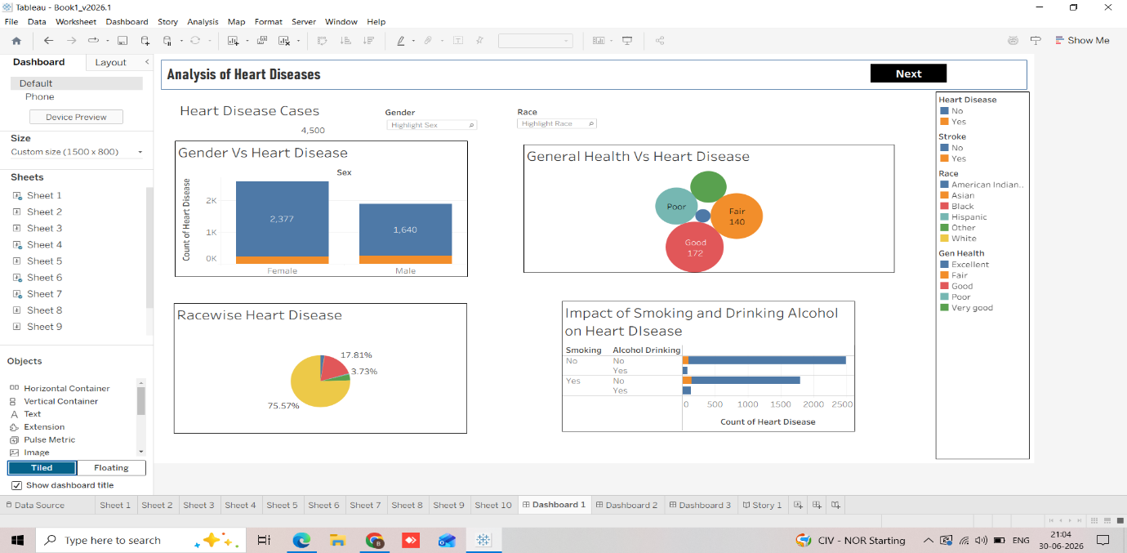

Tableau Public Dashboard
https://public.tableau.com/views/HeartDiseaseAnalysis_17829802569990/Sheet1?:language=en-US&:sid=&:redirect=auth&:display_count=n&:origin=viz_share_link

Future Enhancements
- Integrate the dashboard into a Flask web application.
- Add predictive analytics using machine learning.
- Enable real-time data updates.
- Deploy the application on a cloud platform.

Author
B. Hima Vani Sarma
B. Tech Student | Data Analytics & Visualization Enthusiast

License
This project is intended for educational and academic purposes.

